SKIN CANCER DISEASE PREDICTION SYSTEM

Problem Statement:
Skin illnesses are among the most common health concerns worldwide, necessitating prompt and correct diagnosis. However, diagnosis frequently relies on dermatologists' competence and might be influenced by factors such as low contrast between lesions and skin, as well as visual similarities between healthy and affected areas.
To address these problems, there is an increasing demand for automated, computer aided diagnostic solutions that provide dependable support. This project's goal is to diagnose skin illnesses from photos by using noise-reduction filters, converting them to grayscale for better analysis, and extracting critical features for reliable assessment. The technology improves diagnostic accuracy and consistency, allowing clinicians to make more informed judgments. This technology promotes early identification, enhances patient outcomes, and helps healthcare practitioners determine the severity and urgency of skin disorders.
System Architecture: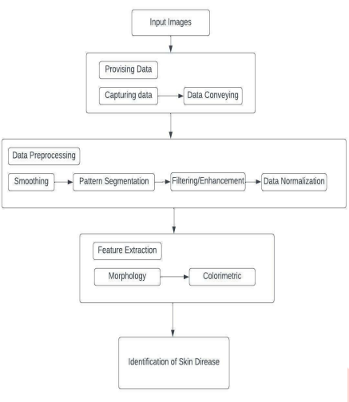
Software Requirements Specification (SRS)
Skin Cancer Disease Prediction System
1. Introduction
1.1 Purpose
The purpose of this document is to specify the software requirements for the Skin Cancer Disease Prediction System, an AI-based application that assists in early detection and classification of skin cancer using medical images. This SRS serves as a reference for developers, evaluators, and academic reviewers.
1.2 Scope
The system analyses user-uploaded skin lesion images and predicts the type of skin disease using a Convolutional Neural Network (CNN). It provides a classification result along with a confidence score to support early diagnosis, especially in areas with limited access to dermatologists.
The system:
- Accepts dermoscopic or skin lesion images
- Performs preprocessing and feature extraction
- Classifies diseases using a trained CNN model
- Displays prediction results via a user-friendly interface
2. Overall Description
2.1 Product Perspective
The system is a standalone, PC-based application developed using Python and deep learning frameworks. It follows an incremental/iterative development model allowing repeated improvement of preprocessing, training, and evaluation stages.
High-level workflow (as per system architecture and flow diagram):
- Image upload
- Image preprocessing
- Feature extraction
- CNN-based classification
- Result visualization
2.2 Product Functions
- Upload skin lesion images
- Preprocess images (resize, normalize, denoise)
- Train CNN model on labelled datasets
- Predict skin disease class
- Display disease name and confidence score
2.3 User Classes
User Type | Description
General User | Uploads images and views predictions
Medical Practitioner | Uses system for preliminary diagnosis
Administrator | Manages dataset and model training
2.4 Operating Environment
- OS: Windows 11 (64-bit)
- Programming Language: Python 3.x
- Frameworks/Libraries: TensorFlow / PyTorch, OpenCV, NumPy, Scikit-learn, Flask (optional UI)
3. Functional Requirements
3.1 Data Handling
- FR1: The system shall load labelled skin disease datasets (e.g., HAM10000).
- FR2: The system shall validate dataset format (CSV + image directory).
- FR3: The system shall handle missing or invalid dataset paths gracefully.
3.2 Image Preprocessing
- FR4: The system shall resize all images to 224×224 pixels.
- FR5: The system shall normalize pixel values to the range 0–1.
- FR6: The system shall remove noise and enhance image quality.
- FR7: The system shall perform data augmentation (rotation, flipping, scaling).
3.3 Model Training and Evaluation
- FR8: The system shall build a CNN model for feature extraction.
- FR9: The system shall train the CNN using pre-processed data.
- FR10: The system shall evaluate model performance using accuracy, precision, and recall.
3.4 Prediction
- FR11: The system shall accept a new image for prediction.
- FR12: The system shall output the predicted skin disease class.
- FR13: The system shall display a confidence score with the prediction.
4. Non-Functional Requirements
4.1 Performance
- Image prediction time shall be under 5 seconds on standard hardware.
- Model training shall support GPU acceleration if available.
4.2 Usability
- The user interface shall be simple and intuitive.
- The system shall allow image upload with minimal user interaction.
4.3 Reliability
- The system shall handle invalid images without crashing.
- Prediction results shall be consistent for the same input image.
4.4 Security
- Uploaded images shall be used only for prediction and not stored permanently unless required.
- No personal user data shall be collected.
4.5 Scalability
- The system shall support future extension to additional skin diseases.
- The model architecture shall allow replacement with advanced CNNs (e.g., ResNet, EfficientNet).
5. System Architecture
The system follows a modular architecture consisting of:
- Dataset Manager
- Image Preprocessing Module
- CNN Model Module
- Prediction & Result Module
- User Interface
6. Assumptions and Constraints
6.1 Assumptions
- Input images are clear and reasonably well-lit.
- The dataset is correctly labelled.
- Users understand that the system provides decision support, not final medical diagnosis.
6.2 Constraints
- Requires a minimum system with Python environment support.
- Model accuracy depends on dataset quality and diversity.
7. Future Enhancements
- Support for more skin diseases (eczema, psoriasis, acne).
- Cloud-based deployment.
- Android mobile application.
- User profile and prediction history tracking.
- Real-time image capture and prediction.

